Coursera : Introduction to MATLAB programming

Week 8 : Lesson 7 : Data Types

Assignments

Character vector

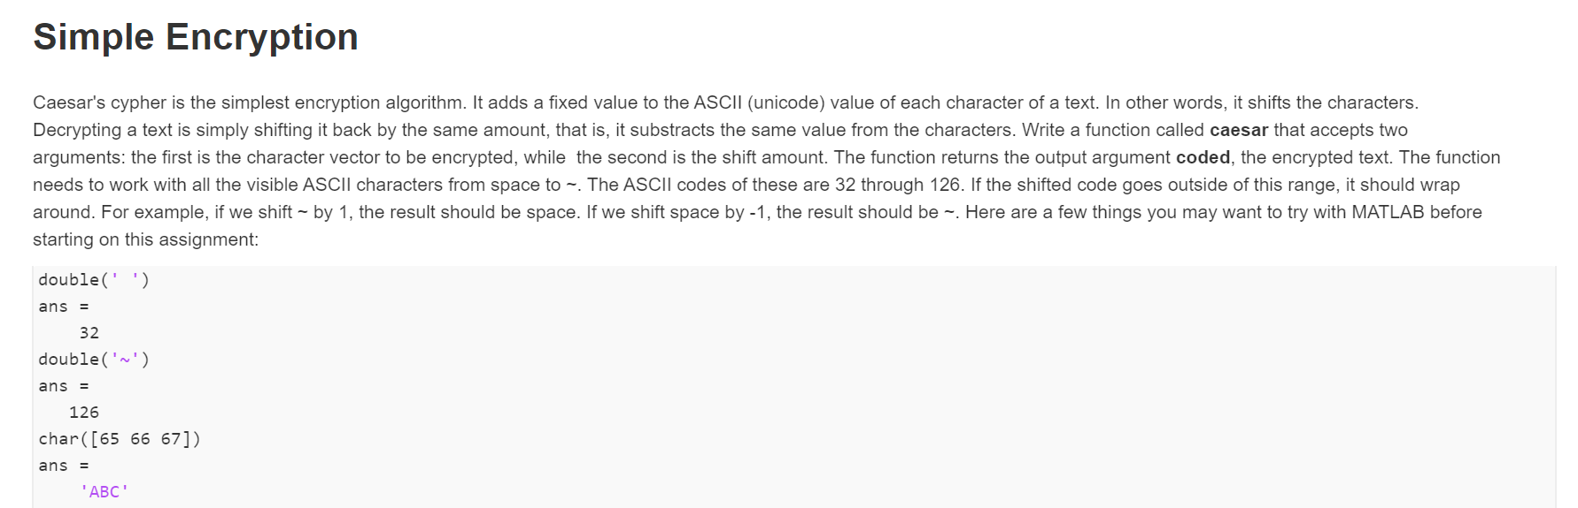

Ans:

function coded = caesar(M, n)

num = double(M); %Converts string into double

num2 = num;

N = mod(n,95);

for i = 1:length(num);

if num(i) + N < 32 %If ASCII value goes below 32

num2(i) = 126 - (31- num(i) - N);

elseif num(i) + N > 126 %If ASCII value goes beyond 126

num2(i) = 32 + (num(i) + N -127);

else

num2(i) = num(i) + N ; %If ASCII value goes normal

end

coded = char(num2);

end

Using Cell Array

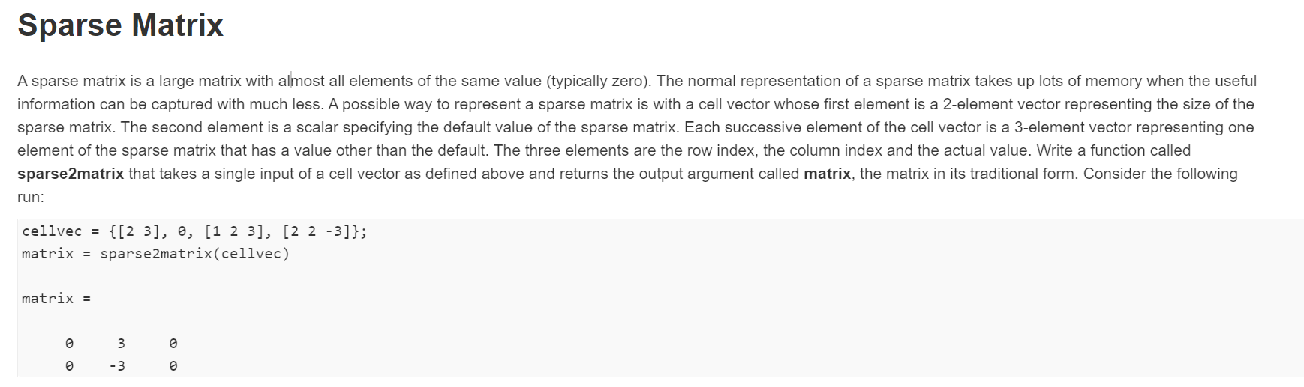

Ans

function A = sparse2matrix(cell)

A = cell{1,2}\*ones(cell{1,1}(1),cell{1,1}(2));

for i=3:length(cell)

A(cell{1,i}(1),cell{1,i}(2))=cell{1,i}(3);

end

end